Design and Implementation of a Complaint Management System Using Spring Boot and MySQL
Table of Content
Introduction iv
Aim and Objectives iv
Problem Statement v
System Architecture v
Technology Stack vi
Implementation of Project vi
Backend Structure vii
Database Design vii
REST API Endpoints vii
Validation viii
Error Handling viii
Results and Testing ix
Challenges and Solutions xi
Conclusion xii
Future Enhancements xii
References xiii

List of Figures and Tables
Figure 1 System Architecture Diagram 3
Figure 2 Error Handling Test Result SS 6
Figure 3 Post Method Testing API Result 6
Figure 4 Get Method Testing API Result 7
Figure 5 Get by ID Method Testing API Result 7
Figure 6 Put Method Testing API Result 8
Figure 7 Patch Method Testing API Result 8
Figure 8 Delete Method Testing API Result 8

Table 1 REST API Endpoints vii

Introduction
The contemporary organisation like a university, corporate office or any service oriented firm, the complaints management is a topic of paramount importance in ensuring the quality of the services and customer satisfaction. These organisations must deal with many complaints every day, which are connected to technical problems, administrative mistakes, waiting time, and dissatisfaction of users. The most of these complaints have been done manually either using paper work, email or isolated networks. These modes of operation usually create inefficiencies such as latency in responding, handling, and inability to monitor the status of complaints. The users end up feeling disregarded whilst organisations are unable to continue being transparent and accountable. The absence of the structured system provides a problem of storing complaint information in a systematic way and accessing them as and when required (Padiku et al., 2024). The absence of adequate track mechanisms, complaint resolution progress and patterns are hard to monitor and improve on. The limitations indicate that a reliable and automated system should be employed to handle complaints effectively. To resolve these problems, the Complaint Management System created with Spring Boot and MySQL is presented in the framework of this project. The system means to offer a digital environment with which complaints are created, stored, updated, and monitored using RESTful APIs. Through the organized data management, data validation and detection of errors, the system will be consistent and reliable. Not only will this solution increase efficiency in terms of its operations, but it will also enhance the user experience, as it allows them to respond quicker and monitor the process of dealing with complaints more efficiently. The system can be extended in the future to accommodate further features like user authentication, reporting features and real-time notifications that makes it appropriate to use in practice in organisations (Mandliy and Solanki, 2024).

Aim and Objectives
The main purpose of the present project is to create and build a Complaint Management System based on Spring Boot that would allow dealing with complaints with efficiency and help to handle such complaints in a systematic and automated manner. The system is aimed at increasing better monitoring, managing, and solving complaints in an organisation.
- To implement the RESTful API using Spring Boot for handling client requests and responses effectively.
- To integrate the MySQL database for structured and persistent storage of complaint data.
- To provide full CRUD (Create, Read, Update, Delete) operations for managing complaint records.
- To apply validation techniques to make data accuracy and consistency.
- To implement error handling mechanisms to manage unexpected situations and provide meaningful feedback.
- To make system stability and reliability throughout its operation.

Problem Statement
Most organisations, the management of complaints is done manually or semi-digitally which in most cases is inefficient and untrustworthy. The most common methods of recording complaints are by the paper forms, emails, or simple spreadsheets, which makes it challenging to handle, and it may also contain a lot of mistakes (Ismail, 2022). These traditional systems are not properly organised and therefore the complaints end up being lost, duplicated or even disregarded. When the number of complaints create a problem, administrators cannot effectively monitor and handle every one of them. The long response and resolution durations can be described as one of the key issues with such systems. The absence of a centralised platform does not offer a clear workflow on how to process complaints and hence the handling time on complaints is slow. The lack of transparency causes users to have low confidence in the system as they find it hard to keep track of their complaints. Users will be unhappy when their concerns are not promptly met or when they do not get any feedback on the progress. The proper data analysis cannot be supported through such systems and it is difficult to detect recurring issues or even increase the quality of services inside organisations. All in all, the unavailability of automation, tracking, and accountability are inefficiencies and harmful to user experience. The proposed project will address these problems through the creation of the automated and organized system of handling complaints through modern technologies.

System Architecture
Complaint management system is developed on a layered architecture, and it breaks the application down into several components, depending on the task they are supposed to perform (Oguntosin et al., 2021). This strategy improves the organisation, maintenance and scalability of the systems. The architecture is designed in an easy flow of communication between layers, which is as follows: Controller Service Repository Database. The Controller Layer deals with the inbound communications incoming as HTTP requests by users or clients. This is its entry point and a mapping of API endpoints to definite functions. The controller takes the input provided by the users in the structure of the JSON data and handles the request and responds to the client. This is free of business logic, that is, it keeps the code clean and on point request handling. The Service Layer is the location of the business logic of the application. It takes the information obtained by the controller, imposes a set of validation rules and decides how the system should react to this information. This layer makes sure that processes like creation, updating or recovery of complaints are done appropriately. Separating business logic and the controller helps to make the system more modular and easier to maintain. Generator Layer. The Repository Layer is the interface between the database and the application (Redelinghuys et al., 2020). This provides the implementation of CRUD operations without the need to execute the SQL query manually with the help of Spring Data JPA. This layer makes accessing data simpler and it is also more efficient in the development of the database because it has built-in ways of communicating with the database.
DB Layer classifies all the data pertaining to a complaint in a well-structured format and uses MySQL to save the data. This keeps logs of information about users, descriptions of complaints, their status and timestamps. Hibernate is software that automatically systems the database schema depending on entity specifications making sure the application and database are in sync. Besides these layers, there is smooth flow of data between the components in the system. When a client delivers a request, it is first accepted by the controller which will be redirected to service layer to perform the operation and thirdly it will be processed by the repository to interact with the database. The answer is then relayed in the opposite direction to the user. This hierarchical movement enhances the efficiency of the system and minimizes the complexity. This layered architecture guarantees a well-defined separation of issues, highest level of readability, and the system can easily scale as the system receives additional features.
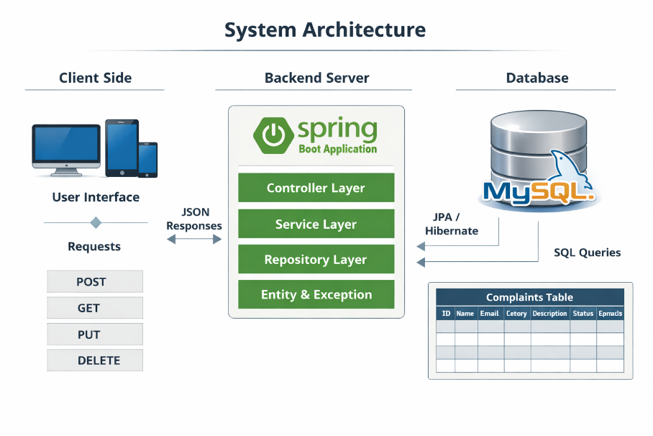
Figure 1 System Architecture Diagram

Technology Stack
The Complaint Management System has been developed using a combination of the modern technologies, which provide efficiency, scalability, and reliability. The core program language is Java 17 because it is stable, object-oriented, and it is adopted in industries widely. This also offers a good basis in creating safe and serviceable applications. The core framework chosen is spring boot since it makes development of any application easier through its in-built configurations, less boilerplate code, and quick development of a RESTful API. Spring Data JPA is applied to handle database operations. This also does not require the complexity of writing multi-line SQL query expression since it offers ready-to-use methods of accessing data and thus speed up development. The relational database of complaints is selected to be MySQL because it is very reliable, and having high performance and has a very easy network with Java programs (Győrödi et al., 2020). Maven is deployed as a dependency and build management tool and makes sure that all the necessary libraries are configured and maintained accordingly. The API endpoints can be tested with Thunder Client which make developers to fire HTTP requests and test system functionality as they develop.

Implementation of Project
The use of the Complaint Management System is dedicated to creating organized backend with Spring Boot that provides a good means of manipulating the data on complaints and communicating effectively with the database. The architecture is structured after the best practices of the modular programming, improving maintainability, scalability, and readability of the code.

Backend Structure
The back end of the application is structured into several packages which handle a certain functionality. The controller package obtains the incoming HTTP request, and assigns it to suitable endpoints (Mabotha et al., 2025). This is the point of contact between the client and server. Business logic of the application is enclosed in the service package, and all operation connected with complaint processing are executed there. The repository package takes care of database access with the Spring Data JPA, which makes CRUD operations without handwriting SQL statements. The data model is defined by the entity package that describes the composition of the table of complaints in the database. The exception package handles errors by specifying custom exceptions and exception global handlers, to make sure the system reacts well to the runtime errors.

Database Design
The system has MySQL as the relational database system that records complaints. The information related to complaints is handled in one table called complaints. There are some key fields in the table. The id field is the primary key and automatically generated. The user who makes the complaint has the information in the name and email fields. The category field defines the type of complaint, i.e. technical or service complaint. The description field includes a description of the problem. Status field reflects the present position of the complaint, which can be OPEN, IN_PROGRESS, or RESOLVED (Alameri, 2018). There are also createdAt and updatedAt fields to monitor the time at which the complaint was created and the time at which the complaint was last modified. These timestamps are automatically handled with JPA life cycle methods. REST API Endpoints

REST API Endpoints
The system includes a collection of the RESTful API entry points to carry out all significant functions on complaints. The new complaint is created via the POST method by sending data in the form of JSON. The GET method fetches complaint records, all complaints or a particular complaint. UPT can be used to edit all information in an existing complaint. The PATCH approach updates fields, i.e., the status of the complaint, but does not change the whole record. DELETE technique deletes a grievance in the database. Such endpoints allow users to communicate with the system in an effective and efficient manner and execute all the necessary operations.
Table 1 REST API Endpoints
Method | Endpoint | Purpose
POST | /api/complaints | Create a new complaint
GET | /api/complaints | Fetch all complaints
GET | /api/complaints/{id} | Fetch a complaint by ID
PUT | /api/complaints/{id} | Update a full complaint
PATCH | /api/complaints/{id}/status | Update only complaint status
DELETE | /api/complaints/{id} | Delete a complaint

Validation
Validation is applied to make data integrity with annotations implemented by Jakarta Validation. The name, category, and description are not left blank because the annotation is the @NotBlank. The Annotation like the @Email annotation confirms that the email address offered by the user is in the right format (Sheng et al., 2018). Such validations eliminate the possibility of the storing invalid or incomplete data in the database, and enhance the reliability and consistency of the system.

Error Handling
The system is configured to handle a global exception handler that is annotated with the @ControllerAdvice exception. This enables the system to handle exceptions centrally, and provide consistent responses to errors. Exception Custom exceptions like the complaint not found exception are devised to deal with situations when a requested record is not found. In case of a mistake, the system will present some meaningful messages rather than general server errors, enhancing user experience and facilitating easier debugging.
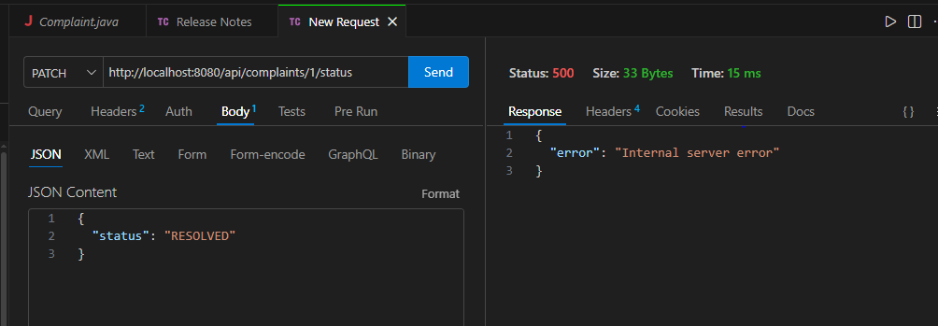
Figure 2 Error Handling Test Result SS

Results and Testing
The Thunder Client, a lightweight API testing tool, was used, and it is embedded in the Visual Studio Code to complete the stage of testing the Complaint Management System (Sagarra, 2025). With the help of this tool, it was possible to easily test all the REST API endpoints using the HTTP requests and examination of the responses that the server provides. The testing procedure was used to verify the functionality of every system and that the backend was correctly networked with the MySQL database.
The POST technique was first tested to establish new complaints records. The request made by sending the JSON response with the user-specific response and the details of the complaints to the system allowed storing the information in the database and providing a response in the form of 201 (Created) status code. The complaint ID generated and times stamps formed part of the response as well, which seems to signal that the record has been saved properly.
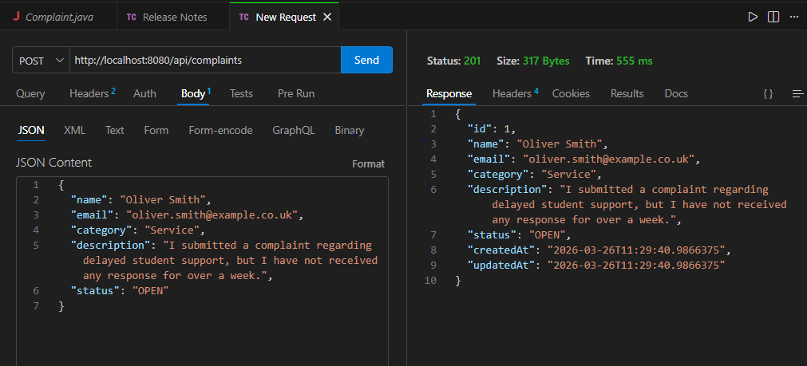
Figure 3 Post Method Testing API Result
All the records of complaints were then gathered out of the database using the GET method. The system gave a 200 (OK) status code at which it gave a list of complaints in the form of a JSON. This showed that the system would be able to access and depict stored information. The GET by ID endpoint was used and tested to recall a certain complaint by using its unique identifier. The appropriate complaint information was sent back valid data were retrieved.
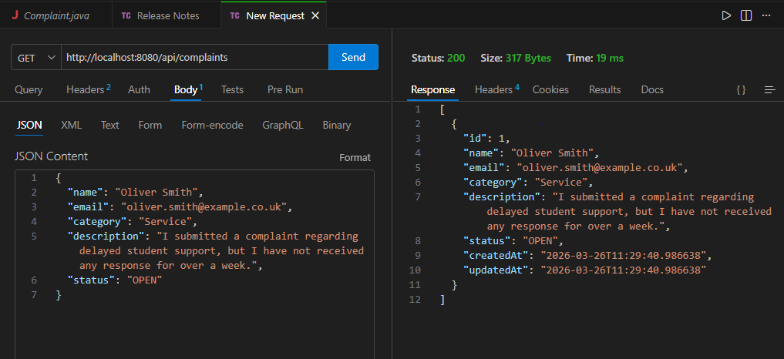
Figure 4 Get Method Testing API Result
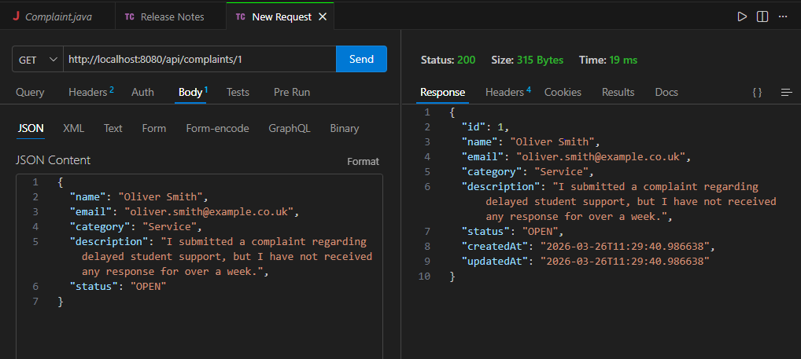
Figure 5 Get by ID Method Testing API Result
The Put method was chosen to make changes in an existing complaint, with a full body of the JSON information that has been changed as well (Rasool et al., 2019). The system responded to the request and gave the updated complaint back with a response back code of 200 (OK) which meant that the update operation was successful.
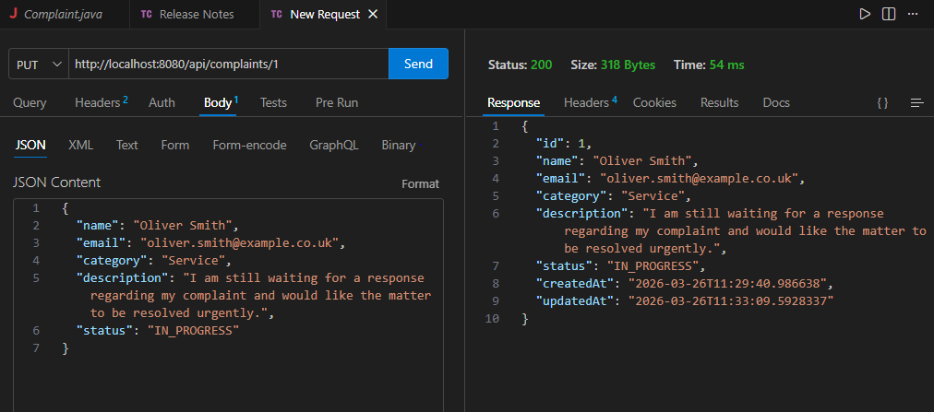
Figure 6 Put Method Testing API Result
The PATCH technique was tested to implement changes on the status of the complaints. The system also allows part of the update by updating a specific field when a request, in the form of the JSON, received a new value of the status, which is unrelated to other data.
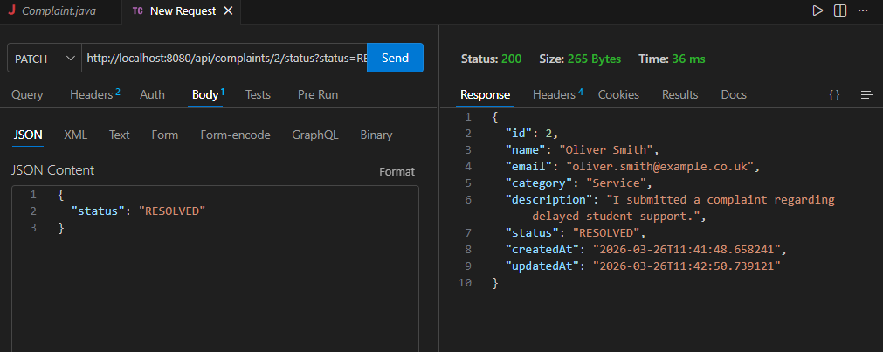
Figure 7 Patch Method Testing API Result
The DELETE procedure was also tried to loot a complaint out of the database. The system was able to delete the mentioned record and give a 204 (No Content) status code, which led to the confirmation of the fact that the requested operation was carried out without errors.
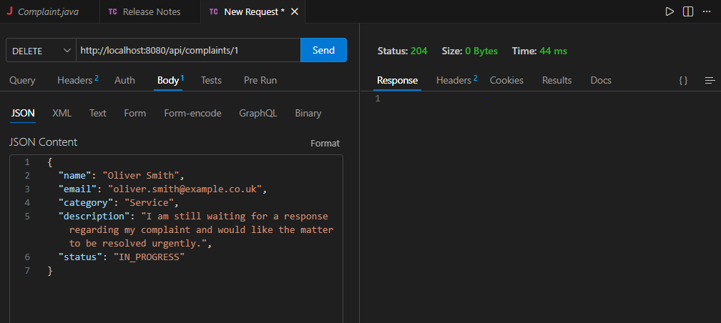
Figure 8 Delete Method Testing API Result
The functional testing, validation and error handling were assured in this stage also. The invalid inputs like wrong email formats or the absence of necessary fields were put to test to make sure that the system displays useful error messages. These tests were done to ensure that the validation mechanisms were in place and so erroneous data was not being stored.

Challenges and Solutions
The development of the Complaint Management System, some problems were met, and they were solved by undertaking step by step debugging and configuration changes. The major problem was associated with the database connectivity. First, the application was unable to connect to MySQL database because of the improper configuration settings like lack of the database name and authentication issue. This was sorted by updating properly the application. Properties file by replacing the incorrect database URL, username and password with correct ones and by making sure that the database is created and started (Teimoor, 2021). The other difficulty was on errors to do with validation. During test of the system, invalid or incomplete data led to unexpected behaviour. This has been solved by the creation of validation annotation like annotation like @NotBlank and annotation like email that only validated and entire information is received by the system. Mistakes with API URL also made troubles while testing. Matched wrong endpoint formatting (i.e. the lack of including http:) or incorrect paths led to failure of requests. All these were fixed by ensuring the API URLs in Thunder Client were specified and rectified. Lastly, there was a mistake done when testing the PATCH method because of wrong request format and body type. The problem was resolved by making sure that the post was written in the form of JSON and the proper endpoint format is used.

Conclusion
To sum up, the Complaint Management System effectively shows the creation of an organized and effective backend-based application on the Spring Boot and MySQL. The project has tackled the shortage of manual complaint handling systems through a digital system that allows the proper handling of complaints about storage, tracking and management. The set goals were met and included the use of the RESTful APIs, integration of databases, CRUD operations, validation, and error handling. The system was properly tested and all functions worked correctly returning correct responses and status codes. This is an affirmation that the application is sturdy and capable of managing complaint data effectively. One of the other important aspects of the project is the use of backend development in the current day application since it provides an effective approach to processing of data, logic of system and management of the database. The system has a solid base foundation on the real-world application and may be further elaborated to suit higher requirements in organisations.

Future Enhancements
The current system performs its core functions effectively, but several increasement can further improve its capabilities and usability in real-world scenarios.
- The important improvement is the addition of the user authentication and login functionality to ensure secure access and role-based control for different users.
- The frontend interface using technologies such as React can be developed to provide a more user-friendly experience and better interaction with the system (Kasenda et al., 2024).
- Many features like search and filter options can be introduced to allow users to easily find specific complaints based on category or status.
- Email notifications can also be integrated to inform the users about updates or changes in complaint status in real time.

References
Alameri, A., 2018. Front-line service employees' service recovery performance: a practice theory-based study into customer complaint handling in the Abu Dhabi Police Force. Nottingham Trent University (United Kingdom).
Győrödi, C.A., Dumşe-Burescu, D.V., Zmaranda, D.R., Győrödi, R.Ş., Gabor, G.A. and Pecherle, G.D., 2020. Performance analysis of NoSQL and relational databases with CouchDB and MySQL for application’s data storage. Applied Sciences, 10(23), p.8524.
Ismail, Z.A., 2022. Exploring e-complaint method: learning from the Malaysian Polytechnic institutions. Journal of Facilities Management, 20(3), pp.501-519.
Kasenda, R.Y., Tenda, J.O., Iman, E.W., Manantung, J.A., Moekari, Z.J. and Pantas, M.C., 2024. The role and evolution of frontend developers in the software development industry. Jurnal Syntax Admiration, 5(11), pp.5191-5196.
Mabotha, E., Mabunda, N.E. and Ali, A., 2025. A dockerized approach to dynamic endpoint management for RESTful application programming interfaces in internet of things ecosystems. Sensors, 25(10), p.2993.
Mandliya, R. and Solanki, S., 2024. Enhancing user engagement through ML-based real-time notification systems. International Journal for Research in Management and Pharmacy, 13(9).
Oguntosin, V., Oluwadurotimi, M., Adoghe, A., Abdulkareem, A. and Adeyemi, G., 2021. Development of a Web-Based Complaint Management Platform for a University Community. Journal of Engineering Science & Technology Review, 14(1).
Padiku, I.R., Takdir, R. and Paneo, A., 2024. Improving Complaint Service Effectiveness with Web Mobile-Based Complaint Service Information System. @ is The Best: Accounting Information Systems and Information Technology Business Enterprise, 9(1), pp.31-45.
Rasool, R.U., Najam, M., Ahmad, H.F., Wang, H. and Anwar, Z., 2019. A novel JSON based regular expression language for pattern matching in the internet of things. Journal of Ambient Intelligence and Humanized Computing, 10(4), pp.1463-1481.
Redelinghuys, A.J.H., Basson, A.H. and Kruger, K., 2020. A six-layer architecture for the digital twin: a manufacturing case study implementation. Journal of Intelligent Manufacturing, 31(6), pp.1383-1402.
Sagarra, A., 2025. Development of a natural language to structured API data processing system with a smart home use case demonstration.
Sheng, Y., Tata, S., Wendt, J.B., Xie, J., Zhao, Q. and Najork, M., 2018, July. Anatomy of a privacy-safe large-scale information extraction system over email. In Proceedings of the 24th ACM SIGKDD International Conference on Knowledge Discovery & Data Mining (pp. 734-743).
Teimoor, R.A., 2021. A review of database security concepts, risks, and problems. UHD Journal of Science and Technology, 5(2), pp.38-46.

